Member(s) of staff responsible: Nicholas Lane
Date Revised: September 2022

Governing committee/sub-committee responsible: Teaching and Learning

EDUCATIONAL VISITS policy
A copy of this policy is available to all governors and parents via the school website or a hardcopy on request from the School Office. It is accessible to all staff electronically (in the Policy folder on the Staff Admin Drive) and a hardcopy held on file in the Head’s Office. This policy applies to all at the school including those in Reception (the EYFS).

Contents
1. Aims of this Policy 3
2. Compliance 3
3. Definitions 3
4. Overview 4
4.1. The SAGE Variables 5
Staff (EV Team) 5
Activities 5
Group 5
Environment(s) 5
A range of planning and management requirements 6
5. Legal Requirements and Responsibilities 6
5.1. Governors (Employer) 6
5.2. The Headteacher 6
5.3 Educational Visits Co-ordinator (EVC) 7
5.4 Visit Leader 7
5.4.1. The Visit Leader must take the following with him/her on the Visit: 9
5.4.2. Good leadership habits 10
5.4.3. Lessons from Accidents 10
5.5 Staff 11
5.6 Supervisors 12
5.7 The Base contact 12
5.8 Children 12
5.9 Parents 13
6. Group Management 13
6.1 Head counts 13
6.2 Supervision 14
7. Financial Arrangements: 15
8. Reconnoitre 16
9. Medication and Pocket Money 16
10. Mobile Telephones and Children’s Property 16
11. Risk Assessment of the Trip 16
12. Residential Visits 17
12.1. Fire safety 19
12.2. Visit Leader accommodation arrival checklist 19
13. Educational Visits Outside of the UK 20
14. Child Protection & Safeguarding 21
15. Disability, Medical and Special Educational Needs 21
16. Consent 22
17. Insurance 22
18. Transport 22
18.1. Tube or Train Travel 23
18.2. Minibuses 23
18.3. Coaches 23
18.4. Private Cars 24
18.5. Taxis 24
19. First Aid 24
20. Accidents and Emergencies 25
21. Reporting Procedures Following an Incident 27
22. Adventurous Activities and External Providers 27
23. COVID 19
24. Procedures for Organising an Educational Visit 28
24.1 Procedure for Category 1 Sports fixtures/tournaments 28
24.2 Procedure for Category 1 day trips and extended day trips 29
24.3 Procedure for Category 2 trips 30
Appendix A: List of Forms Available 31
Appendix B: Application for the Approval of an Educational Visit 32
Appendix C: Guidance for Supervisors 32
Appendix D: Checklist of Information that May be Included in a Letter to Parents 34
Appendix E: Emergency Procedure for the Visit Leader 35
Appendix F: Code of Conduct for Residential Trips 37
Appendix G: Checklist for Visit Leader at Point of Departure: 38
Appendix H: Evaluation Form 40
Appendix I: Statutes and Further Guidance 41

- Aims of this Policy
At Finton House School we are keen to promote trips as we believe they make a very valuable contribution to children’s education. In particular, they provide the children with opportunities to undergo experiences not available in the classroom and to develop their investigative skills. In addition, there are opportunities to attend residential trips in Years 3-6, which encourage greater independence and the development of social skills.
The School also recognises and accepts that such visits may present an increased risk to the health and welfare of children. Educational Visits will therefore be planned and operated in accordance with this policy and guidance so that everyone involved understands his/her responsibilities and can participate fully in learning outside of the classroom as safely as possible.
All Educational Visits will be suitable for the age, maturity and capabilities of the children.

- Compliance
This policy has been adopted from the OEAP National Guidance. Staff should refer to this guidance at http://oeapng.info/ as well as this policy. In the event of any apparent conflict between this policy and the National Guidance then this school policy must be followed and clarification sought from the EVC or Headteacher.

- Definitions
3.1. ‘Educational Visit’ (EV) includes but is not restricted to the following activities: off-site visits, workshops and activities, study and cultural visits, hazardous and adventure activities and expeditions, overseas trips and residential trips.
3.2. ‘Category 1 Sports’ are regular fixtures and tournaments with and hosted by other schools, with departure and return times between 08:00 and 17:30. The School office will be base contact for these trips.
3.3. ‘Category 1 Day Trips’ are EVs that do not include ‘adventurous activity’, with departure and return times between 08:00 and 17:30 taking place during term time. The School office will be base contact for these trips.
3.4. ‘Category 1 Extended Day or Sports Trips’ are EVs that do not include ‘adventurous activity’, with either departure and/or return times outside the hours of 08:00 and 17:30 taking place during term time. The School office will be base contact for these trips between 08:00 and 17:30, but there also needs to be an independent Base Contact who is aware of the trip itinerary and is available by phone at all times until the trip returns safely to School. The Visit Leader must contact the Base Contact to let them know when the trip has returned to School.
3.5. ‘Category 2 Trips’ are EVs that include a residential aspect, travelling abroad or adventurous activities. The School office will be base contact for these trips between 08:00 and 17:30, but there also needs to be an independent Base Contact who is aware of the trip itinerary and is available by phone at all times until the trip returns safely to School. The Visit Leader must contact the Base Contact to let them know when the trip has returned to School.
3.6. ‘Adventurous Activities’ include, but are not restricted to, activities such as winter sports, rock climbing, hill walking, mountaineering, caving, climbing, trekking, water sports or activities in or around water. An activity may be considered to be hazardous not only due to the nature of the activity itself but also the environment in which it will take place, to include but not restricted to activities in areas subject to extremes of weather, temperature or environmental change, on or near cliffs or steep terrain, or in or near water.

3.7. ‘Governors’ [or ‘Employer’] in relation to Finton House Educational Trust, means the Board of Governors.
3.8. ‘'The School’ means Finton House School, trading as Finton House Educational Trust.
3.9. ‘The Educational Visits Co-ordinator’ (EVC) is the member of staff with delegated operational responsibility, ensuring the planning of each trip is completed thoroughly and appropriately, offering advice throughout the process and prior to departure.
3.10. ‘Visit Leader’ means an employee who has overall responsibility for the organisation, supervision and conduct of the Educational Visit.
3.11. ‘Staff’ is defined as anyone who holds a contract of employment with Finton House Educational Trust.
3.12. ‘Supervisor’ is any competent and or confident adult, aged 18 or over who has responsibilities and duties assigned to him/her during an Educational Visit. This includes volunteers.
3.13. 'Base Contact' is the person the Visit Leader will contact first if there is a problem on the trip. During normal School hours (8.00am-5.30pm) this is the main School Office. Outside of these hours a Base Contact must be nominated and agreed by the Visit Leader.
3.14. ‘Parent’ means those having parental responsibility for a child, including carers and guardians.
3.15. ‘Adult’ means anyone on the visit that is over 18 years old.
3.16. ‘EV Team’ means any adult on the visit.
3.17. ‘Group’ means everyone on the EV, including children
3.18. ‘External Provider’ means any person or organisation other than the School or employee of the School who provides a service and or facilitates an activity under a contract during the Educational Visit.
3.19. ‘Plan B’ means an alternative activity in the event the planned activity on an Educational Visit cannot be undertaken safely.

- Overview
National Guidance starts from three basic premises:
- Well planned and facilitated opportunities to learn in the real world, away from the classroom, and to experience adventure, helping to improve the lives of children.
- Delivering learning outside or off-site does not need to be more difficult than delivering it inside a classroom. Planning and management should, therefore, be practical, proportionate and non-bureaucratic.
- The key to effective and successful outdoor learning and off-site visits is:
The right leaders doing the right activities with the right children in the right places at the right times.

4.1. The SAGE Variables
This means that the following ‘SAGE variables’ must be considered in the planning, management and delivery of visits:
Staff Activities Group Environment(s)

Staff (EV Team)
While all activities and visits must have a single, designated, competent leader, getting the competence and composition of the EV Team right is the single most important factor in the effective management of outdoor learning and off- site visits.
Competence is a combination of skills, knowledge, awareness, judgement, training and experience. It is not related to age or position within the establishment.
Competence:
- is situational – a leader who is competent in one activity or environment may not be so in another;
- involves breadth as well as depth - relevant experience is not necessarily gained by repeating the same thing several times, but by experiencing a range of different activities and environments.
The other SAGE variables, either alone or in combination, create the circumstances that the EV Team will have to manage. Managing a visit involves:
- Matching the activities and environments to the aims of the visit, and to the needs and abilities of the children.
- Ensuring that the competence of the EV Team is appropriate.

Activities
Activities vary in range and suitability. Both the planned learning activities and any supplementary activities, such as those associated with travelling, ‘free time’ and accommodation, etc., must be considered. Some activities may require specific training or qualifications; some may need specialist equipment; and some may require a particular level of competence or prior training of the children.

Group
The age, competence, maturity and behaviour of the children must be matched to the other variables, and any individual, medical or special needs addressed. If a group comprises more capable children, and there is appropriate leader competence, it should be possible for the group to experience a more challenging range of activities and/or environments.

Environment(s)
All environments and venues present their own challenges for the management of a group of children. Considerations include whether the environment is indoors or out; a public space or restricted access; urban, rural or remote; quiet or crowded; within the establishment grounds, close to the establishment or at a distance and the ease of communications between the group and base. The time of day/night, season of the year and weather conditions can also affect the complexity of the environment, and hence the considerations.

A range of planning and management requirements
The SAGE variables do not operate in isolation and the interplay between them should be planned for and managed. As an example, consider an annual visit which has run successfully for the past few years, but this year one variable changes (such as an experienced leader has left, or the weather is far worse than previously, or the children are more ‘difficult’ than before): suddenly it is no longer the right people in the right place, doing the right things - and that’s when things can go wrong.

- Legal Requirements and Responsibilities

5.1. Governors (Employer)
Under the Health and Safety at Work etc. Act 1974 the employer is responsible for the health, safety and welfare at work of their employees. This duty extends to everyone involved in Educational Visits (to include but not restricted to staff, supervisors, volunteers, children and members of the public).
The role of the school governing body is to enable and ensure; otherwise described as being a critical friend.
The Governors will make sure that:
- they have an understanding of how Educational Visits support a wide range of outcomes for the children;
- they have access to the national guidance as well as this policy;
- there is an EVC in place that meets with employer requirements;
- there are formal notification and approval procedures in place;
- this EVC policy supports the principles of inclusion;
- there are monitoring procedures in place;
- they satisfy themselves that risk assessments have been carried out, that appropriate safety measures are in place and that training needs have been addressed for Educational Visits;
- they ensure that the Headteacher, EVC or Visit Leader can show how their plans comply with legislation, regulations and guidance, including the School’s Health and Safety policy. These duties apply at all times to all Educational Visits in the UK and abroad;
- they retain the legal responsibilities under the health and safety legislation but delegate the statutory tasks to the Headteacher.

  - The Headteacher
The Headteacher will:
- ensure that Educational Visits comply with legislation, regulations and this guidance as well as the School’s Health and Safety policy;
- usually delegate operational responsibility to the EVC. If there is no named EVC the functions of the EVC will automatically be attached to those of the Headteacher;
- be informed of any non-compliance with the terms of this policy and with general health and safety responsibilities. Non-compliance will be taken seriously and may result in disciplinary action;
- confirm that the EVC is competent to plan, undertake and supervise activities, and to monitor/assess the risks throughout the Educational Visit;
- Ensure that the EVC has significant experience of practical off-site activity and visit leadership;
- Ensure that the EVC has status within the Establishment that enables them to guide the working practices of their colleagues;
- Ensure that significant time is given to the EVC to fulfil their role.

If the Headteacher takes part in the visit as Staff or a group member, the Visit Leader still retains sole charge of the visit.

5.3 Educational Visits Co-ordinator (EVC)
The EVC is responsible for overseeing the planning, reviewing the activities, and for monitoring and assessing the risks of Educational Visits. The EVC will ensure that:
- they have attended EVC training as recommended by the employer, and that this training is kept up-to-date;
- they have an understanding of how outdoor learning, off-site visits and learning outside the classroom can support a wide range of outcomes for children and raise achievement;
- the School’s EVC policy is up-to-date with current legislation;
- the Visit Leader is competent to plan, undertake and supervise activities and to monitor/assess the risks throughout the Educational Visit. The EVC will also ensure that all staff and supervisors are properly vetted;
- Wherever possible the school will use venues which hold a LOtC badge which are found here https://www.lotcqualitybadge.org.uk/search
- Educational Visits meet the School's requirements and that the visit has a specific and stated objective;
- any relevant qualifications claimed by the Visit Leader or other relevant members of the group have been checked and verified and are up to date;
- the School’s EVC policy provides sufficient guidance to Visit Leaders about information to parents, and parental consent where required;
- those who are conducting the risk assessments have the necessary qualifications, knowledge, skills and experience to do so. Also to ensure that risk assessment(s) for the planned Educational Visit and any Plan B have been completed and appropriate health and safety measures are in place;
- there is adequate insurance cover, liaising with the Bursar who may need to consult with the School’s insurers and insurance advisers where appropriate;
- the address and telephone number of the venue of the Educational Visit, as well as a contact name are recorded;
- there is a Base Contact, available on a 24/7 basis, for each and any visit outside of normal School hours;
- medical and first aid issues, as well as emergency contacts for children and staff being referred to during a visit are up-to-date and addressed;
- there are contingency plans and emergency arrangements for each Educational Visit and assess the efficiency of those arrangements;
- a final review of all paperwork has been undertaken before being passed to the Headteacher for permission to be given for the trip to go ahead;
- he/she monitors and retains records of Educational Visits, including reports of accidents, near misses and safety concerns, and reviews policies in light of these issues. For all Educational Visits, records must be retained on file for three years. If a child under the age of 18 has been injured on an Educational Visit, records must be retained until that child reaches the age of 21;
- he/she reviews systems, proactively monitors practice and addresses non-compliance in consultation with the Headteacher;
- Ensure that systems and procedures are reviewed.

5.4 Visit Leader
The Visit Leader is responsible for the planning, undertaking and supervision of an Educational Visit. The Visit Leader has:
- responsibility for the planning of the Educational Visit including the preparation of proper paperwork and risk assessment(s) in consultation with the EVC with a view to ensuring the safety and welfare of children, staff and supervisors attending;
- responsibility for the supervision during the Educational Visit;
- responsibility for the conduct of children, staff and supervisors during the Educational Visit, ensuring that the good name of the School is upheld. (see Code of Conduct appendix F)
- ensure that supervisors have read and understood the Guidance for Volunteers on Trips (Appendix C)
To ensure accountability and to avoid potential confusion, a single Visit Leader should be appointed. If this role changes during a visit, a clear handover should be made and the Group and Base Contact made aware.
The key requirements for Visit Leaders are that they must be accountable, confident and competent to lead the visit/activity, not that they hold a particular post, title or job description.
Being accountable means that the Leader has been engaged through an appropriate recruitment process, which includes vetting and induction into the establishment’s policies and procedures. The details of this process may depend upon whether the Leader is employed, contracted or acts as a volunteer, but in all cases should be thorough. Regardless of a leader’s employment status, they should understand the chain of accountability, what is expected of them, and the school’s policies and procedures.
Being confident includes leaders having the ability to take charge of a situation while being aware of, and understanding, their abilities, as well as their limitations.
Being competent means that the leader has demonstrated the ability to operate effectively, and has sufficient relevant experience and knowledge of the activities, the group, and the environments in which the visit will take place.
Competence is a combination of skills, knowledge, awareness, judgement, training and experience. It is not necessarily related to age or position within the establishment. It is situational – a leader who is competent in one activity or environment may not be so in another, and it involves breadth as well as depth. Relevant experience is not necessarily gained by repeating the same thing several times, but by experiencing a range of different activities and environments.
For adventure activity leaders, competence is best demonstrated through:
- Holding a National Governing Body leadership/coaching award at an appropriate level, or
- Being "signed off" by a suitably-qualified Technical Adviser appointed by the employer.
The following can be considered evidence of competence:
- Providing evidence of holding relevant qualifications, including any specific qualifications required by the law or the School (e.g. First Aid);
- National Governing Body awards and qualifications;
- Local or in-house validation.
The Visit Leader will:
- follow legislation, regulations, guidance and the School’s policies;
- obtain approval in principle for the Educational Visit from the Headteacher and ensure the trip is entered into the school calendar;
- undertake to ensure the completion of comprehensive risk assessment(s) for both the Educational Visit, and any Plan B in the event that the primary activity is undeliverable, using the appropriate generic forms as a starting point.
- prepare an appropriate plan B and ensure that everyone on the Educational Visit is aware of the arrangements in the event of an emergency;
- provide adequate information to Parents regarding the Educational Visit in order to obtain informed parental consent, and obtain such consent where appropriate. Regardless of whether consent is required or not, all parents must be informed that a trip is taking place, including activities which take children offsite.
- for any residential and EV abroad, arrange a pre-EV meeting between parents/children/EV Team.
- liaise with the EVC and Bursar in order to ensure that adequate insurance is in place and that all insurance conditions are complied with;
- obtain relevant medical information for all children and EV team attending the Educational Visit.
- appraise himself/herself of children’ special educational and/or medical needs which may be relevant to the Educational Visit and liaise with others where appropriate;
- ensure that there is sufficient first aid provision for each Educational Visit (see section 19);
- obtain and carry emergency telephone numbers and details of emergency points of contact and communicate with the Base Contact and EVC where appropriate;
- if it is possible, carry out a reconnoitre trip.
- take immediate steps to terminate the Educational Visit if there are unacceptable risks to the health or safety of the children or to anyone else on the Educational Visit;
- ensure that all children and parents are aware of the standard of behaviour expected on all Educational Visits and the consequences of breaching those standards;
- report any incidents, accidents or near misses to the EVC or other relevant staff, and review the trip with the EVC upon their return.
- report back to the EVC for post trip analysis after the visit;
- have the full authority of the Headteacher and have the right to return any child home if, after consideration of all relevant matters and consultation with the Headteacher, s/he is of the opinion that such action is warranted. Extra costs arising out of any such event will be payable by the Parent(s);
- liaise with the Bursar to calculate the cost of the trip and the recharge to parents (if appropriate);
- define the roles and responsibilities of the whole EV Group (including children) to ensure effective supervision, appointing a deputy wherever possible;
- if the EV Team includes someone with a close relationship to a member of the group, ensure there are adequate safeguards so that this will not compromise group management;
- ensure the whole EV Team and any third party providers have access to emergency contact and emergency procedure details;
- never delegate responsibility for supervision to anyone unless they are suitably confident;
- when working with third-party activity providers it is imperative to avoid ‘grey areas’, so there should be a clear handover before and after any activity led by a provider. Should a provider run an activity in a way that causes concern, the accompanying staff/supervisors should consider stopping the activity at the first appropriate moment. Such an intervention should be done with sensitivity and discretion to ensure that it does not result in children being put at greater risk.

5.4.1. The Visit Leader must take the following with him/her on the Visit:
- all documents covering booking, travel arrangements and accommodation;
- copies of visit paperwork, including signed medical consent forms;
- insurance details and documents;
- passport documents (where appropriate);
- details of medical and emergency contacts for the group;
- a detailed itinerary (where appropriate) ;
- an appropriate first aid kit, including individual medication (inhalers, epi-pens, etc) and Health Care Plans;
- bucket/bowl, tissues, bin liners;
- kit bags (where appropriate);
- water;
- driving licence if driving;
- road map (when driving);
- a debit/credit card, or means to access emergency funds;
- a full list of the group members;
- details of weather forecasts (where appropriate);
- details of nearest hospital (residential and visits outside M25 only);
- Hi viz jackets for staff;
- one, and preferably two, mobile telephones with charger;
- Spare clothes (LS only).
- Check the children have a packed lunch/tea (where appropriate);

A copy of all relevant information should be retained by the School Office. For trips outside normal hours, the Base Contact and Headteacher must also hold a copy.

5.4.2. Good leadership habits
- Stay alert – develop a leader’s ‘twitch’ or a 360ᵒ awareness of the group and environment so that you pick up changing circumstances quickly.
- Remain flexible and look for the unexpected – the things that you hadn’t considered in planning. All visits should be well planned but it is not possible to anticipate everything, so leaders must be ready to adapt the plan to changing circumstances. Changes in circumstances can provide excellent learning opportunities but it is important to distinguish between a threat and an opportunity. Example: on a city centre visit you see a crowd gathering in a square. This may be an interesting piece of street theatre or a peaceful protest, which could be used as a stimulus for good follow up work. Alternatively it could be the beginnings of a violent protest that you should not be near.
- Don’t be a ‘turkey’. Turkeys base their assumptions on their own past experience and simply expect to get food and water every day right up to the time they don’t. Applying past experience to new circumstances does not always work so just because things have always gone well on your visits do not assume they always will. Learn from others’ experience and learn from accidents.
- Be a ‘swan’. Swans appear to float gracefully and serenely across the surface of the water, but underneath their feet are busy and quietly directing. Leaders should present an outward impression of calm reassurance so that the group is able to enjoy their trip. This is only achieved, like the swan, by constantly keeping your senses working - monitoring, reviewing and planning.
- Ask yourself the ‘What If?’ question. What if one of them slips off this path? What if that crowd in the square turns nasty? What if the bus breaks down? By constantly asking yourself these questions you will be ready to respond – quickly if necessary.
- Look for lemons! Accidents rarely have only one cause. They often occur because several factors (each in isolation not critical but often common place) come together at the same time - like lemons lining up in a slot machine. Spotting lemons and discussing them with colleagues may help you to avoid this unwanted ‘jackpot’. Example:
- Children acting silly and pushing one another over is not that uncommon.
- Rain and wet roads/pavements is not that uncommon.
- Car drivers being momentarily distracted is not that uncommon.
- Children crossing roads during an educational visit is not that uncommon. However, if these occur at the same time, so that you have a group of children pushing each other, so that one falls over, while crossing a wet road in front of a distracted driver, the potential outcome is a serious accident.

5.4.3. Lessons from Accidents
- PLAN B – Always prepare a ‘Plan B’ (even if this is simply that you turn around and go back to base). The more complex the visit the more complex the Plan B may be. Ensure everyone is aware of the Plan B. DO NOT be afraid to switch to Plan B – psychologically it is often easier to carry on with Plan A: be aware of this and do not delay switching plans. It is better to wonder later if you were too cautious than to regret not changing plans when you had the chance.

- CLEAR ROLES – Ensure all members of the EV Team and the group are aware what their role is and what is expected of them. The Visit Leader is responsible for ensuring that all members of the EV Team know the travel arrangements, the types of activity permitted, the emergency contacts, the special needs of individual children and the arrangements for welfare.

- ACTIVE SUPERVISION – supervision is not simply a passive presence: it is an active employment of the leadership habits outlined above – supervision is about what leaders do, not just that they are there.

- PREPARE WELL – ‘Proper Planning and Preparation Prevent Poor Performance’. A well thought out plan, including what to do in the event of an emergency, should provide leaders with all the options they need to lead an effective visit. Involve children in planning and keep them informed of developments and changes.

- BE WATER AWARE – There are very few fatal accidents on visits but, statistically, drowning is the single biggest cause of them. The water environment provides wonderful opportunities for play, enjoyment and challenge but does require careful supervision. Water should not be avoided on visits but should be treated with respect. The best way to help children to be safe around water is not to keep them from it but to teach them to swim, teach them safe practices around water and teach them to recognise safe from dangerous locations. Remember that water hazards exist on the water margins, even if you are not planning to enter the water. For further advice on managing activities in and around water see the documents “Group Safety at the Water Margins”, “Natural Water Bathing” and “Swimming Pools” by going to http://oeapng.info/

- SAY NO – Visit Leaders tend to want to please, and a group of children desperate to do something that they were looking forward to is difficult to resist. Leaders MUST be strong enough to act upon their judgement. If, for example, children are expecting to paddle during a trip to the local river and your judgement is that something has changed since you planned the trip and this is no longer a good idea, then you say NO.

5.5 Staff
Under the health and safety legislation, all staff must:
- take reasonable care of their own and others’ health and safety;
- co-operate with their employer over safety matters;
- carry out activities in accordance with training and instructions;
- inform their employer of any serious risks.
All staff assisting with trips are ambassadors of the School, whether the Educational Visit takes place within normal working hours or outside those hours or even term time and therefore they must always comply with the relevant school policies, procedures and protocols.
Staff also have a common law duty to act towards children as any reasonably prudent parent would do in the same circumstances. However, in some circumstances such as where staff specialise in a particular activity or lead more hazardous or adventure activities there may be a higher duty of care.
All staff involved in EVs must have read and understood this policy. They will also:
- comply with the instructions of the Visit Leader and help with control, behaviour and discipline;
- do their best to ensure the health and safety of everyone on the Educational Visit and speak to the Visit Leader or EVC if concerned about the health or safety of anyone attending the Educational Visit;
- consult with the Visit Leader and, where appropriate, take immediate steps to terminate the visit if there is an unacceptable risk to the health or safety of children or anyone else on the Educational Visit;
- be aware of potential conflicts of interest if their own children are members of the group and discuss this beforehand with the Visit Leader and the EVC;
- be sufficiently competent to take over the Visit Leader role in case of emergency;
- have a reasonable prior knowledge of the children, including any special educational needs, medical needs or disabilities;
- carry a list/register for all group members;
- apply the appropriate type of supervision, as required by or agreed with the
Visit Leader;
- have the means to contact the EV Team if needing help;
- be alert for and recognise unforeseen hazards and respond accordingly;
- have read, signed and dated all risk assessments relevant to the school visit;
- ensure that children abide by the agreed standards of behaviour.

5.6 Supervisors
All Supervisors will:
- be properly vetted, DBS checked and assessed in accordance with the School's Child Protection & Safeguarding Policy by the Visit Leader (with assistance from the EVC and Bursar) prior to the visit;
- have read signed and dated all risk assessments relevant to the school visit;
- not be left in sole charge of children except where it has been previously agreed as part of the risk assessment;
- do their best to ensure the health and safety of everyone in the group and should speak to the Visit Leader or the EVC if concerned about the health or safety of anyone attending the Educational Visit;
- follow the instructions of the Visit Leader and staff and help with control, behaviour and discipline;
- be aware of potential conflicts of interest if their own children are members of the group and discuss this beforehand with the Visit Leader;
- comply with all relevant school policies such as Staff Conduct Policy, the Behaviour Policy including sanctions and rewards, etc.
- have a reasonable prior knowledge of the children, including any special educational needs, medical needs or disabilities;
- carry a list/register of all group members;
- apply the appropriate type of supervision, as required by or agreed with the
Visit Leader;
- wear high-viz jackets when walking on the streets with children;
- have a clear idea of the activity to be undertaken, including its aims, objectives and targeted learning outcomes;
- have the means to contact the EV Team if needing help;
- be alert for and recognise unforeseen hazards and respond accordingly;
- be competent in techniques of group management.

5.7 The Base contact
The Base Contact is the nominated person who will hold a copy of the EV paperwork on a 24/7 basis. This will give them access at all times to all details of the visit, including medical details and emergency contacts for all children and the EV Team. The Base contact should have a paper copy of key information in case electronic information is not accessible.
The Base Contact should expect to be in contact with the Visit Leader throughout the trip. They should expect calls or texts at various key times, e.g. once the trip has safely arrived at their destination, and once the trip has returned. The Base Contact should also be contacted immediately if any member of the trip is unwell, if the itinerary needs clarifying or amending, or if there is any problem on the trip, including a delay to the arranged return time. The Base Contact should then contact the EVC and Headteacher.
The Base Contact should contact the Visit Leader if the trip is not back at the expected return time. If they are unable to contact the Visit Leader, the EVC and/or Headteacher must be notified immediately.
The Base Contact must be contactable for the duration of the trip, and be in a clear state of mind at all times. This means, for example, that alcohol intake by the Base Contact must be minimal (i.e.: always being under the legal limit for driving in the UK).

5.8 Children
The Visit Leader will make it clear to children that they must:
- Not put themselves or others at unnecessary risk;
- Follow the instructions of the Visit Leader, staff and Supervisors;
- Uphold the Finton Values and abide by the school rules, maintaining acceptable standards of behaviour at all times;
- Dress and behave sensibly and responsibly, using safety equipment as instructed;
- Follow the kit list supplied and bring clothing that is appropriate to all anticipated temperature and weather conditions. Specialist equipment must be identified separately from clothing;
- Wear School uniform or kit unless permission has been given for other clothing;
- If abroad, be sensitive to local codes and customs;
- Know who their leader is at any given time and how to contact him or her;
- Make sure that they have understood instructions;
- Make sure they are not isolated from the group;
- Know who their fellow sub-group members are;
- Alert the leader if someone is missing or in difficulties;
- Make sure they are aware of any designated meeting place;
- Make sure they understand the action they should take if they become lost or separated.

5.9 Parents
Parents can and should contribute to the success of the visit by:
- understanding and reinforcing the objectives and educational aims of the Educational Visit;
- reinforcing the standard of behaviour and conduct expected of their child on the Educational Visit;
- providing clear information on their child's health and/or any special needs, including the need for medical attention or medication;
- ensuring that they provide their up to date contact details (during the time of the trip) and other appropriate contact details in the event they will be unavailable.
To ensure Parents are able to fully support the School and achieve these aims, it is important that letters are sent out via Finton Post at least 2 weeks before a Cat 1 trip giving sufficient details to allow parents to up-date contact details, provide additional information, or in any other way query the visit. Cat 2 trips require a much greater lead time, usually during the preceding term, to allow families to plan their own diaries.
Please remember, parents may request copies of the risk assessment, emergency plans and other planning documents from the EVC. If a Parent takes part in a Visit as a member of the EV Team, they will have another role within the supervision arrangements for the visit: care must be taken to ensure that the role of Parent does not conflict with this other role.

- Group Management

6.1 Head counts
Regular head-counts of children should take place throughout all off-site activities. The frequency will need to be increased at certain points such as crowded public areas, getting on and off transport, and when arriving at or leaving a location or near a significant hazard (such as water). A head count should always be part of any initial response to an incident or emergency. It is easier to monitor and count smaller groups and clusters.
It is good practice to:
- Double-check numbers before departing from a venue, with at least two members of staff making the count.
- Carry a list/register of all children and adults involved in the visit at all times.
- Ensure that younger children are readily identifiable, especially if the visit is to a densely populated area, e.g. school uniform can help identify group members more easily.
- Avoid identification that could put children at risk e.g. name badges.
- Use the school wrist bands
- Provide extra safeguards for very young children (such as the wrist bands), or for those with special needs, such as providing laminated cards displaying the name of the group or hotel and an emergency contact number. This could be appropriate for all visits abroad, with a translation of the information into the relevant language(s).
- Ensure that everyone is aware of rendezvous points.
- Ensure that everyone knows what to do if they become separated from the
group e.g. tube briefing drill.
- Make everyone aware of their destination e.g. the tube station where the plan requires them to get off.

6.2 Supervision
Supervision must be considered as part of the risk assessment and any concerns should be referred to the EVC and Head.
There shall be an adequate ratio of adults to children in order to supervise children during each Educational Visit. Ratios should become closer the more complex or hazardous the venue or activity. The Visit Leader will liaise with the EVC to make arrangements for another appropriately vetted and qualified person to join the party and take over responsibilities in the event of the incapacity of or injury to the Visit Leader and/or any of the EV Team where appropriate.
Where an adult is a parent of a child on the visit that parent shall not usually count in the ratio for the group as a whole. Special mention of any parent with children on the same Educational Visit must be noted and considered in the relevant risk assessment.
The Contingency Plan shall make provision in the event of an emergency or incident, within the specified ratios of adults to children, for a different member of the EV Team to:
- deal with any emergency or incident;
- seek emergency and/or medical assistance and communicate with the emergency contact at the School;
- supervise the remainder of the party.

For local low risk visits in normal circumstances (non-residential trips) and subject to any special considerations, the following ratios may be appropriate; however staff should remember that there are no set ratios for visits. Visit Leaders need to take into account the experience of the staff and supervisors, the activity itself, the needs of the group and individuals within it, the environment and the distance from base. See SAGE in section 4.1.
Ratios are a risk management issue, and should be determined through the process of risk assessment. It is not possible to set down definitive adult/child ratios for a particular age group or activity.
These should be regarded as starting points for consideration rather than being definitive, as they may be appropriate only where the activity is relatively straightforward and the group has no special requirements. For example, the DfES publication HASPEV (1998) suggests the following “starting points”:
  - Reception = 1:6*
  - School years 1 – 3 = 1:6
  - School years 4 – 6 = 1:10/15
Without special safeguards or control measures, these ratios will not be adequate to meet the needs of most residential or more complex visits.
*The Early Years Foundation Stage (EYFS) Statutory Framework no longer sets out different requirements for minimum ratios during outings from those required on site. As with other age groups, ratios during outings should be determined by risk assessment, which should be reviewed before each outing.

Ratios for Adventurous Activities differ from activity to activity due to the varied risk.
Remote Supervision occurs when a group works at such a distance that direct supervision would take some time to be re-established (e.g. during a remotely supervised adventure walk; children travelling independently to a venue; an orienteering activity). For this form of supervision to be appropriate a decision must be made that the children no longer require an adult leader but are capable of operating independently. Supervision in this context is more of a monitoring and emergency response role. Although the supervisor is not physically present they should be able to intervene or assist within a reasonable time when contacted or if there is a cause for concern (reasonable in this context will depend on the age, maturity and competence of the group, the activity and the environment). For this to be effective, the group must know how to make contact with a remote supervisor. When supervision is remote:
- Groups should be sufficiently trained and assessed as competent for the level of activity to be undertaken, including first aid and emergency procedures.
- children should be familiar with the environment or similar environments, and have details of the meeting points and the times of rendezvous.
- Clear and understandable guidelines will be set for the group, including physical and behavioural parameters.
- Parents should be made aware of the nature of supervision and the level of responsibility and independence expected of the children.
- There must be clear lines of communication between the group, the supervisor and the establishment.
- The supervisor should monitor the group’s progress at appropriate intervals.
- There should be defined time limits between contacts. Exceeding these limits should activate an agreed emergency procedure.
- There should be a recognisable point at which the activity is completed.
- There should be clear arrangements for the abandonment of the activity where it cannot be completed without compromising safety.
Supervision problems are most likely to occur when groups stray into a type of supervision that is less closely controlled than that which was planned. For example, the leader intends to exercise indirect supervision but sets such wide and vague boundaries that the group is really being remotely supervised without this being properly planned or prepared for. The Visit Leader should select the type of supervision to maximise the educational benefits while appropriately managing the risks. Clearly the SAGE variables (Staff, Activity, Group, Environment) all need to be considered before moving away from direct supervision.
It is essential that everyone involved in the activity, including parents/guardians, understands the supervision arrangements and expectations.

- Financial Arrangements:
The School reserves the right to charge for Educational Visits, accommodation, equipment and other related costs. Such costs may be added to the child’s fees at the end of the term, or a more immediate payment may be required.
If payment is not received, or School fees are outstanding, the School reserves the right to exclude children from Educational Visits.
Parents must be made aware of the costs of a trip, and consent gained.
It is important we can demonstrate clear transparency financially. This means we can show how the cost of the trip has been arrived at, and that every child is charged the same amount. Children on bursaries are not expected to pay for residential trips but do pay for day trips.
Parents will be informed of the arrangements for sending a child home early due to poor behaviour for example. Parents will normally be required to meet the costs of such arrangements. The School will not be obliged to refund the cost of the remainder of the visit.
When working out the cost of an Educational Visit, please remember to include a 10% contingency to cover the cost of unexpected extras, or children who drop out (e.g. through illness on the day). It is best to include all costs, and to give a realistic global figure to parents. A refund in case of over-estimate is always more acceptable than a supplementary charge.
Once permission has been granted, the cost of the trip is added to the following term’s school fees.
- Reconnoitre
Areas or activities involving significant hazard should have been reconnoitered if at all possible; alternatively reliable information should be obtained concerning the nature of any hazards and means of avoiding or minimising risk.
- Medication and Pocket Money
The Visit Leader must appoint one member of Staff to be responsible for medication, including keeping a record of all medication given, any accidents, etc. This includes the needs of children who self-medicate.
The Visit Leader must appoint one Supervisor (who may be the same Supervisor) to hold and account for pocket money if he or she does not handle these matters him/herself.

- Mobile Telephones and Children’s Property
Children are not to carry mobile phones on visits out of School. The Visit Leader and at least one other member of the EV Team will always set off with a fully charged mobile phone and will ensure that the Base Contact has the relevant numbers.
Parents should be reminded not to send children on Educational Visits carrying expensive equipment that may attract thieves or be lost or broken. In any event, children will be responsible for all items of personal property taken on the Educational Visit.
Staff should not use their own phones to take photographs of the children, however, if a group picture is required to send back to school this may be taken on a phone as long as it is deleted straight after sending. Please see the Acceptable Use Policy for further information.

- Risk Assessment of the Trip
The Visit Leader will consult with the EVC and carry out a full and detailed risk assessment of hazards posed by the Educational Visit using the generic risk assessment forms as a guide. The Visit Leader should use the following generic risk assessments (found on the Staff Drive) as a starting point to create site/trip-specific risk assessments:
- All Visits
- Specific Transport e.g. walking on foot, road, train, flight, etc.
- Any other risk assessment relevant to the trip, for example, camping, farm visits, adventure playground, etc.

Risk assessment must also involve dynamic assessments undertaken in the course of the Educational Visit.
It is acceptable for risk assessments to be completed once and then reused for regular Educational Visits such as Sports Fixtures provided that hazards, risk factors and control measures remain the same, and they are reviewed regularly (at least once a year.) In these circumstances, all other administrative requirements as set out in the Flow Charts in Section 14 should be observed.
Review of risk assessments should take place on return from one off-visits, and as necessary after regular trips/activities. This will help inform any future visits by other staff.
If the Visit Leader is concerned about hazards or risk factors identified by risk assessment(s) he or she should consult with the EVC.
If the EVC considers that the hazards or risk factors identified by the risk assessment(s) are unacceptable then the Educational Visit shall not go ahead.
The contingency plan (Plan B) for any Educational Visit must be dynamic, depending upon individual circumstances, but will include contacting the Base Contact and will often be ‘return to school’. However, be aware that in some settings, the temptation to ‘push on’ when things start to go wrong has led to serious accidents and this temptation may be stronger if the only alternative is to ‘give up and go home’.
Educational Visits outside of the UK will be subject to the law of that country, but if the risk assessment is carried out in the UK, it will also be subject to UK domestic law.
Writing Risk Assessments involves answering two basic questions:
a. What could go wrong?
b. What are we going to do about it?
This process happens at three levels:
- Generic – Policies and procedures that apply across a range of visits (normally recorded)
This is guidance or practice that remains constant regardless of the nature of the visit. It covers the management of risks identified as relevant to all visits involving similar activities.
- Visit-specific – Carried out before the visit takes place (may need to be recorded)
This is the identification and management of any risks not already covered through generic risk management. It is unique to each occasion and should address staffing, activity, group and environment (the ‘SAGE’ variables from section 4.1).
- Dynamic/on-going – Carried out continuously throughout the visit (not necessary to record) This refers to the on-going monitoring of all aspects of the visit/activity by the EV Team. The group and the level of risk must be monitored and assessed throughout and, if circumstances dictate, activities should be curtailed or amended (e.g. change to plan B). In practice, it is often these on-going decisions of the Visit Leader(s) that determine whether the group remains safe and whether the activity is successful. Hence a competent EV Team is essential.
Risk assessment is a part of the overall planning process and not ‘tagged-on’ afterwards. Risk assessment recording is not unduly onerous, but is supportive and helpful for the EV Team.

- Residential Visits
The School will ensure that all off-site accommodation provided for use by children on Educational Visits is satisfactory and, where possible, has been assessed by the School before use and the result recorded on the risk assessment. Where this is not possible, for example: on tours and expeditions arranged through external tour operators or organisations, the School will obtain assurances that the accommodation provided is of a satisfactory standard, and seek references from other schools, where appropriate.
In particular, the Visit Leader will ensure that accommodation provides:
- sufficient and suitable bed and bedding for each child (or the camping equivalent);
- separate sleeping provision for each gender;
- sufficient access to toilet and washing facilities (separate for each gender if possible) appropriate to the nature of the activity;
- regular provision of sufficient and appropriate food and drink, stored and prepared under sufficiently hygienic conditions to minimise risk of ill-health;
- ability to contact medical services, and provision for return to School or home, in case of accident or illness;
- satisfactory and contactable adult supervision who are competent to supervise activities involved and with back up staffing to deal with emergencies.
The School's Child Protection & Safeguarding Policy will apply at all times on all overnight visits and trips abroad.
Children staying in off-site accommodation on Educational Visits will be supervised at all reasonable times by staff or supervisors.
- On arrival check the rooms, security arrangements and evacuation arrangements and ensure everyone is clear about what to do in the event of an emergency. The fire evacuation procedure for an overnight stay must be explained to every member of the group by a designated person as soon as possible after arrival at the venue.
- Hold evening briefings with EV Team to review issues and prepare for the next day.
- Spend time early in the morning explaining/confirming arrangements for the day to the group.
- Recognise that many health problems on longer visits are caused by lack of food, of liquid or of sleep.
- The sleeping accommodation is exclusively for the group’s use or rooms are located next to each other, ideally on the same floor.
- If the accommodation is being shared with another school group, the joint expectations of EV Teams and children are shared and agreed.
- EV Teams have sleeping accommodation providing easy access to their group. Consider location of leaders when children’ rooms are not in close proximity to each other.
- Consider the most appropriate allocation of children to rooms.
- Where shower and toilet facilities are not en-suite, consider arrangements for
managing the use of shared facilities.
- Consider how secure the buildings can be made against intrusion and if there is 24 hour staffing of reception.
- Confirm that rooms or areas can be secured. If individual rooms can be locked, the EV Team must have access to a master key.
- Ensure everyone knows the emergency procedures, fire escape routes and
assembly points.
- Ensure children know the location of their accommodation (carrying a hotel card from reception is a simple and effective idea).
For Overnight stays, residential visits or visits outside of the UK: at least two of the EV Team will be staff. Mixed gender groups should have at least one male and one female supervisor/staff.
The responsibility for supervision is continuous, 24 hours a day. It is important that care and supervision are maintained during periods outside structured activities, as well as during the activities themselves. This does not mean that children need necessarily to be constantly watched, but rather that the EV Team need to achieve a sensible balance of activities and supervision methods.
Time for children to be with their peers, away from a close adult presence, can be an important part of visits, particularly during residential experiences, and brings many additional learning opportunities. This is equally true for structured learning time as it is for recreational time on longer visits. However, too much unstructured time can allow opportunities for mischief, bullying, homesickness and wandering off, so the time needs to be appropriately managed. Opportunities for such time should be built into the visit plan with appropriate levels of supervision, be included in information to parents (and their consent) and be covered by the risk- benefit assessment.
It is good practice to:
- Take care with the use of terms such as ‘free time’ and ‘down time’ so that they do not suggest to the EV Team or children that supervision will not be in place.
- Ensure that all leaders and children understand the standards of behaviour that apply at all times, not just during activities.
- Ensure that a leader duty system operates so that groups continue to be appropriately supervised at all times, and that any handover of responsibility is made clear.
- Have strict guidelines for behaviour in bedrooms and dormitories.

12.1. Fire safety
- Check fire safety standards as part of the accommodation selection process.
- From a fire rescue perspective it may be better not to sleep above the sixth or seventh floor (the limit of external rescue by the fire services) so as to make evacuating the building easier.
- On arrival, check fire escape routes to ensure they are properly signed and clear of obstructions.
- Know what the fire alarm sounds like.
- Ensure everyone knows the emergency procedures, fire escape routes and
assembly points.
- Ensure there is an appropriate Personal Emergency Evacuation Plan (PEEP) for any adult or child who may need one.
- Many fires are started by electrical faults. Be aware of electrical appliances fitted in rooms (kettles, hairdryers, heaters, fridge) and ensure children are briefed about any issues about these and electrical items they may carry (hair appliances, chargers, etc.).

12.2. Visit Leader accommodation arrival checklist
- The accommodation is as expected/booked
- Make an initial assessment of the hazards of the accommodation and the immediate surroundings to brief the children about the safety aspects
- Allocate rooms appropriately and keep a list of who is where
- Check toilet and shower areas
- Check fire exit routes are signed, clear and working
- Do you have/can you get access to a master key for rooms?
- Check the security of the building overnight
- Assess the immediate area around the accommodation – is it as expected?
- Assess public areas and decide how these will be managed
Check each room for:
- Breakages, damage or missing items – record and report these
- Windows and balconies
- Door security and locks
- Electrical hazards
- Fire/smoke detectors
- Carbon monoxide sources
- Routes to fire exits
- Mini bar
Brief everyone (either a group briefing or room by room) on:
- Any room hazards (slips, trips, electrics, balconies etc.)
- Use of toilets and showers where these are not en-suite
- Emergency evacuation procedure (consider a fire drill if appropriate)
- Location of leaders overnight
- Boundaries – where they can go
- Behaviour and conduct around the accommodation
- Timings and meeting places
- Educational Visits Outside of the UK
Care should be taken over selection of the supplier of transport and accommodation and firms with ABTA membership should be used where possible. This will be unworkable in some countries; in this instance firms without ABTA membership will require further validation.
The Visit Leader will ensure that each child has their passport and necessary visas and other travel documents before embarking on an Educational Visit outside the UK. The Visit Leader should make a colour copy of all Passports and health cards before the trip departs. These need to be included in the visit paperwork.
The Visit Leader should read the guidance on the Foreign and Commonwealth Office website about the country they are visiting and use their foreign travel checklist to help with planning their Educational Visit.
If possible one of the EV Team should be able to speak and read the language of the country visited, or at the very least be able to hold a basic conversation and know what to say in an emergency.
It is advisable for children to carry a note in the relevant foreign language in case they get lost asking the reader to reunite them with the group and/or take them to the police station. They should also carry the Visit Leader’s name and contact number.
The Visit Leader must ensure that each child knows:
- that s/he may not bring into or take out of the United Kingdom: animals, insects, vegetable matter, flick knifes, real or imitation firearms or other prohibited items;
- all similar rules that apply on arrival in and leaving any country being visited;
- that children under 17 are not entitled to duty free allowances;
- that any child bitten by an animal must seek medical treatment immediately;
- Which direction traffic will approach them;
- Ensure that everyone is aware of cultural expectations and dress, and behaves in a way that avoids offence.
Each Child attending a visit in another EU member state should have a European Health Insurance Card (EHIC) or the newer Health Card. This can be applied for on-line, by telephone or by post and is obtainable free of charge.
See https://www.nhs.uk/using-the-nhs/healthcare-abroad/apply-for-a-free-uk-global-health-insurance-card-ghic/
The Visit Leader must check the trip is covered by the School’s travel insurance.
The Visit Leader must be aware of different environmental hazards e.g. that some diseases are more common in some countries, and know what preventative action to take and what to do if a group member becomes infected.
Medicines which may be legally held in one country may be illegal in another. The rules of any country to be visited should be checked. Medicines should be properly labelled, and prescription medicines should be accompanied by a copy of the prescription. Where medication includes delivery by syringe, it may be necessary to show an accompanying doctor’s note at border security. A personal licence may be required to take certain controlled medicines abroad. This needs to be made clear to parents on the medical form.
In some countries, it is possible to purchase medicines over the counter which would require a prescription in the UK. These should not be used unless prescribed by a qualified medical practitioner.

- Child Protection & Safeguarding
The School’s Child Protection Policy and procedures, including any procedures for vetting, DBS checking and assessing the suitability of staff and volunteers will apply at all times during Educational Visits.
The Visit Leader will carry out the duties of the Designated Person or will name an appropriate adult member of the group to do so.
Any incident amounting to an allegation or suspicion of abuse which occurs whilst on the Educational Visit will be reported immediately to the relevant Designated Safeguarding Lead (DSL). These staff will advise as to how the situation is to be managed. Ways of being able to contact these staff should be considered.
It is the responsibility of the EV Team and all other staff and adults involved, to safeguard and promote the welfare of children during outdoor learning, off-site visits and learning outside the classroom.
Such visits and activities have many benefits, but there are also potential safeguarding risks which should be considered during the planning process.
Visits Leaders should ensure that they are informed of any children and children who may be particularly vulnerable or have specific safeguarding needs, and ensure that the EV Team are made aware as necessary.

- Disability, Medical and Special Educational Needs
The School will make every effort to ensure that Educational Visits cater for and are accessible to all, irrespective of disability, special educational or medical needs, ethnic origin, religion or gender.
Where there are doubts over the inclusion of a child on the grounds of disability, special educational or medical needs, ethnic origin, religion or gender, there will be consultation between the School, the Child and the Parent(s).
If, despite making reasonable adjustments, there remains a significant, unmanageable and unacceptable risk to the health and safety of children or anyone else on the Educational Visit, it may be reasonable to exclude a child from the Educational Visit on those grounds.
A record should be maintained by the School of the reasons for the exclusion of that child from the Educational Visit.
When working with children who are disabled or have special educational needs, the adult-child ratios on visits may need to be increased. The following factors should be considered when determining staffing requirements:
- the need to administer medication.
- the need for a member of staff to accompany a child to the toilet.
- the likelihood of a child absconding.
- the likelihood of a medical emergency arising.
- the way in which being away from the normal setting will affect behaviour e.g. some children have unpredictable fears and phobias which will be more difficult to cope with out of their normal environment.
- the risk of violence/assault.
- the need for manual handling of children.
- the need for restraint, and deployment of trained staff.
- the flexibility for staff working on a 1:1 basis to take a break. Where a member of staff is needed to supervise or care for an individual child, they should not be considered to be part of the overall staffing ratio, as their role will be focused on their charge’s wellbeing, not on the wider supervision needs of the group.
- If a member of staff is driving a minibus, they will not be able to supervise passengers, nor deal with any emergencies en-route and therefore a second adult must be present.

- Consent
Appropriate consent must be obtained from all ‘responsible adults’ for an Educational Visit.
The Visit Leader will ensure that Parents are given sufficient information in writing to give them a true and accurate understanding of the Educational Visit in order to enable them to provide informed consent. A proforma for writing a letter concerning an Educational Visit is available in the School’s paperwork.
Where a Child’s parents are separated, the School must ensure that information about an Educational Visit goes to both parents, unless instructions have been given otherwise. Contact information is available on ‘School Manager’.
Parents give approval for all day trips via FH Post at the beginning of the year. Permission for residential trips is gained by the Visit Leader via FH Post and copies of parental consent are to be taken on the trip with one copy being kept at school.
If consent is refused by one or both Parents, the Child must not take part in the Educational Visit.

- Insurance
There shall be appropriate insurance cover in place for each Educational Visit. Educational Visits will generally be covered by the School’s insurance policy.
If the Visit Leader has any queries about whether a particular Educational Visit will be covered, or wishes to take out additional or alternative insurance, she/he should consult with the Bursar. Parents should be informed of the insurance arrangements made by the School in clear terms. Parents should be told if additional cover for specific events is recommended such as cover for child’s valuable personal possessions or personal injury. If additional cover is required, Parents must be advised to make their own arrangements within the Consent letter.
Parents should be informed that the School cannot accept liability for the failure of insurance for reasons beyond the control of the School or where the School has made reasonable enquiries and exercised reasonable care. This information must be included in the consent letter which goes to Parents.

- Transport
The Visit Leader, as part of the planning and risk assessment of an Educational Visit, shall consider the transport requirements, including contingency planning for cancellation, delay or breakdown of the transport arrangements. A transport risk assessment must be completed for every visit leaving the school site.

The Visit Leader will ensure that the mode of transport is appropriate for the Educational Visit. The Visit Leader should ensure that journeys are properly planned with adequate rest stops and that a second driver is provided, if appropriate.
All transport bookings must be made through the School Office.
If free public transport is to be used, an application needs to be made at least 14 days prior to the trip.

18.1. Tube or Train Travel
The following procedures are followed:
- London Underground staff are available to assist and will alert staff at destination of arrival;
- Everyone goes single file down the escalators, having made sure there are no untied shoelaces or dangling toggles;
- Regular head counts should be made and always by at least two members of staff each time;
- The train is boarded at the front, as this is usually the less crowded carriage and the driver is then aware of the group boarding the train;
- One member of staff gets on first and another is last;
- Staff stand either end of the children in the carriage and have a clear view of children at all times;
- When waiting for and leaving the train, the children line up against the far wall away from the track;
- The children are briefed that if they do not board the train they must stay where they are for a member of staff to return to them. If they fail to get off the train they must get off at the next stop and wait for a member of staff to collect them;
- Wherever possible the children sit down on the train;
- The children all have buddies and are responsible for letting a member of staff know if their buddy is missing at any time;
- Busy times, such as rush hour are avoided wherever possible.

18.2. Minibuses
- Where a minibus is used, the Visit Leader and driver will comply with the School’s Transport Policy.
- The school minibuses have a maximum of 15 children on board at any one time. Seatbelts are to be worn at all times. The school minibuses are not usually used for travelling beyond the M25 orbital route and the drivers of the minibuses are competent and have undertaken suitable minibus training.
- The driver is not responsible for supervising the children during the journey or ensuring acceptable standards of behaviour are met. There is always an additional adult accompanying the driver.
- There are three school minibuses and Wandsworth Community minibuses can also be booked.

18.3. Coaches
- Only coach companies which have been vetted and approved by the School may be used. The Bursar will ensure that the company’s drivers have appropriate DBS checks, licences, insurances and are competent to drive the vehicles concerned. The School Office will book coaches for the Visit Leader.
- Staff must ensure that seat belts are worn and that any overhead equipment is stored away safely. Staff sit throughout the coach and at least one member is at the front, and one by the rear emergency door. If it is a two-storied coach, there is a staff member on both decks.

18.4. Private Cars
- If individual cars are used to transport children the driver must ensure that the vehicle is roadworthy, and that they have a full and valid licence.
- Any child under 135cm in height (approx. 4’5”) will only be allowed to travel if there is appropriate child restraint for their weight in any vehicle.
- Transporting of children by staff or parents is covered by the school’s insurance policy for occasional business use.
- Agreement is sought from parents with regard to their child being carried in individual cars via signing permission slips or verbal consent given on the telephone.
- In the interest of child protection no child should travel on his/her own with another parent or member of the EV Team. If this is unavoidable, the child should sit on the rear seat.

There are specific requirements for Early Years settings. The Early Years Foundation Stage Statutory Framework 2008 requires the following:
“Records should be kept about vehicles in which children are transported, including insurance details and a list of named drivers. Drivers using their own transport should have adequate insurance cover”.

18.5. Taxis
- Only taxi companies approved by the school may be used for school business. Please contact the Bursar in advance of booking.
- Children travelling by taxi should be accompanied by a member of the EV Team.

- First Aid
The determination of the appropriate first aid requirements for an Educational Visit should take into account:
- The nature of the activity.
- The nature of the group.
- The likely injuries associated with the activity.
- The extent to which the group will be isolated from the support of the emergency services (both in terms of distance and response time).
A basic level of first aid support (such as the course undertaken by all staff) must be available at all times. This will require that one or more of the staff leading the activity has a working knowledge of simple first aid and is competent to use the first aid materials carried with the group.
A person qualified in Paediatric First Aid, MUST accompany every trip involving Reception (EYFS) children. For outings involving children from the Early Years, all materials and equipment should be suitable for the needs of these children.
Care must be taken to ensure that children are adequately covered or take shelter in hot conditions. It is a legal requirement that all public service vehicles, including minibuses, must carry a first aid kit, for use by emergency services. It should not be used as a general first aid kit.
The Visit Leader will ensure that there is adequate first aid provision on each Educational Visit.
The minimum first aid requirements for Educational Visits can be discussed with the EVC and will form part of the risk assessment.

Example 1: a walk to the local library on a footpath adjacent to a public road with ambulance access. The school must have first aid provision on site (not necessarily accompanying the group); so must the library. The Visit Leader has some basic knowledge of first aid and is carrying a mobile phone in an area of good reception. A qualified first aider would be a bonus, but is not required.
Example 2: a walk along a rural footpath, with no vehicular access for about 2 miles, to a picnic site. Any significant injury here would involve such a time delay in accessing an ambulance as to make it necessary for there to be someone with appropriate first aid training and expertise as a member of the group, carrying a mobile first aid kit.
Example 3: an outing to the local park by a Reception group. Someone with a current paediatric first aid certificate must accompany the group.
Depending upon the duration and type of visit, it is likely that some children will require medication for the prevention or treatment of minor ailments, for example:
  - Sunburn
  - Travel sickness
  - heat rash
  - insect bites
  - period pains, headaches
  - athlete’s foot
  - indigestion
  - sore throats, colds and coughs
  - cuts and grazes
  - muscle stiffness
Parents must be asked for their permission for staff to administer any medication, including non-prescription medicines. This will be done through the medical form issued prior to a residential trip. Care should be taken with all medication to observe the recommended dosage appropriate to age.
If a condition arises which requires medication which had not been anticipated, parental permission should be obtained, and a doctor’s prescription may be necessary.
It is illegal to give a medicine which has been prescribed for one person to another. This would normally include asthma reliever inhalers. However, from the 1st October 2014, schools are allowed to carry emergency salbutamol inhalers, and use these for children who have been prescribed one. Use of emergency inhalers should be subject to a protocol forming part of the establishment’s medical conditions policy. Government guidance is available at:
https://www.gov.uk/government/uploads/system/uploads/attachment_data/file/360585 /guidance_on_use_of_emergency_inhalers_in_schools_October_2014.pdf
The well-being of children and children should always be given the highest priority: if a child suffers from a life-threatening asthma attack and does not have their own inhaler, then the benefit of giving a blue inhaler from elsewhere is likely to outweigh the risks of not doing so.
- Accidents and Emergencies
During an Emergency you will not have time to read this guidance – you will be reliant on training and effective/practised systems. ALL Emergency Procedures should be regularly tested and all members of a EV Team should feel able to deal with an incident, including alerting the Establishment in the event of an Emergency.

Each member of the EV Team will take a copy of what to do in case of an emergency with them on every visit. See Appendix A.
The Visit Leader will brief all EV Team in the action they should take in the event of an emergency with reference to the Emergency Plan, particularly where there is a risk of death, personal injury, damage to property or involvement with the police.
A serious accident or incident is defined as:
- An accident leading to a fatality, serious or multiple fractures, amputation or other serious injury;
- Circumstances in which a party member might be at serious risk or have a serious illness;
- Any situation in which the press or media might be involved;
- Anything requiring the use of the emergency services or hospitalisation.

In the event of a child going missing, the Missing Child Policy will be used to swiftly locate the child and/or involve parents, authorities or liaise with the media.
The Visit Leader should take charge of an incident until relieved by the emergency services. In the event that the Visit Leader is incapacitated, or unable to take charge, all members of the EV Team should have the competence to take charge and to initiate the school’s Emergency Plan.
- Communications can become swamped in an emergency, particularly if parents/media are trying to call for news. Phone numbers, not in the public domain, should be agreed between Visit Leaders and the Base Contact to maintain communications in the event that primary channels become overwhelmed. Parents should not be given the telephone numbers that activate the school’s Emergency Plan or Critical Incident Plan.
- All members of the EV Team should know how to respond to an emergency.
- The role of the Base Contact can be very demanding when an emergency does occur, and it is important to ensure that the people who have that role are competent. Ensuring competence means choosing the right person and could involve any of the following: having opportunities to think through scenarios and how to react to them; crib cards; training; access to support.
- Always include discussion of Emergency Procedures in any planning meeting and as part of your risk management process.
- Allocate roles. An effective Emergency response requires several things to happen at once and the Visit Leader cannot attend to casualties, ensure that others in the group are moved to a safe place and kept safe, call for help from the emergency services, instigate the Emergency Procedures and keep notes of the incident all at the same time.
- Involve children in planning for incidents and Emergencies – unless there are particular reasons why this would be inappropriate.
- All members of the EV Team should have easy access to a copy of the Emergency Procedures throughout the visit, and know what action to take if there is a problem. Consider laminating the Procedures onto cards.
- Where there will be significant periods of remote supervision, children will also need an appropriate version of the Emergency Procedures. They will also need to be appropriately trained in how to apply them.
- Ensure that there is an appropriate level of first aid and lifesaving cover as necessary for the nature of the visit/activities. Basic first aid is not at all complicated and many lives could be saved each year if more people knew how to open an airway, place a casualty into a safe airway position and deal with major bleeding/shock. Good practical first aid training is an excellent way to provide children with a useful life skill while enhancing their self- esteem and self-confidence. It is also an excellent team building/group work activity.
- Ensure that the first aid kits are appropriately stocked and accessible.
- Ensure that all individual medical needs are known and that the EV Team are competent to handle them.
- Practice emergency drills e.g. evacuation of mini-bus, rapid group collection/head count, fire drills at any accommodation.

- Reporting Procedures Following an Incident
The Visit Leader should ensure that any incident is properly recorded and is reported to the Base Contact, EVC or Senior Leadership Team as soon as reasonably practicable afterwards. If the emergency services are contacted, or a child is taken to hospital, the Base Contact and/or EVC needs to inform the Headteacher immediately. If the emergency services have been called The Headteacher needs to contact the Chairman of the Governors.

Record the following:
- time, date and nature of the incident.
- accurate incident location.
- names of casualties.
- details of injuries.
- actions taken, including all communications.
- names of others involved but not injured.
- details of any moves from the incident site (times, who moved, where to, how).
The Visit Leader shall consult and liaise with the Base Contact and EVC in the event of an incident and follow the Emergency Plan and guidance provided by the School.
Under no circumstances should anyone make a statement to the press or give any admission of liability for any occurrence other than on legal advice; refer any requests for a statement to the Headteacher or Chairman of the Governors.
An Accident or Near Miss Report must be submitted to the EVC within 24 hours of return from the Educational Visit.
- Adventurous Activities and External Providers
Any Educational Visit which involves Adventurous or Hazardous activities should be referred to the Headteacher and involve recognised and suitably qualified persons to organise.
The Visit Leader should:
- obtain and check references from External Providers;
- check if External Providers are required to have a licence to provide Licensed Activities and, if so, that they hold a current licence at www.aals.org.uk ;
- check that the provider holds an AALA licence (if activities are in scope of the Adventure Activity Licensing Regulations)? If activities are not in scope of the regulations and the provider does not hold a LOtC Quality Badge do they have any other form of accreditation e.g. “Adventuremark” or any National Governing Body (NGB) Centre Approval?
- if the provider does not hold a LOtC Quality Badge, what evidence or assurances about educational quality are available?
- agree with the External Provider their respective roles and in particular who is going to be responsible for children during the activity and for what period of time. The Visit Leader, teachers and supervisors retain responsibility for the moral and emotional well-being of children during the activity and should not hesitate to withdraw a child from an activity they judge to be unsafe or causing distress;
- be fully satisfied with arrangements for health and safety. In the event that he/she is not satisfied he/she will consider, in consultation with the EVC whether it is appropriate to abort the activity altogether or whether it is safe and/or appropriate to undertake ‘Plan B’;
- COVID 19
With trips now able to take place, the EV team should make regular use of national guidance OEAP via the following link: https://oeapng.info/downloads/download-info/4-4k-coronavirus/
- Procedures for Organising an Educational Visit

24.1 Procedure for Category 1 Sports fixtures/tournaments
(published in the school calendar).

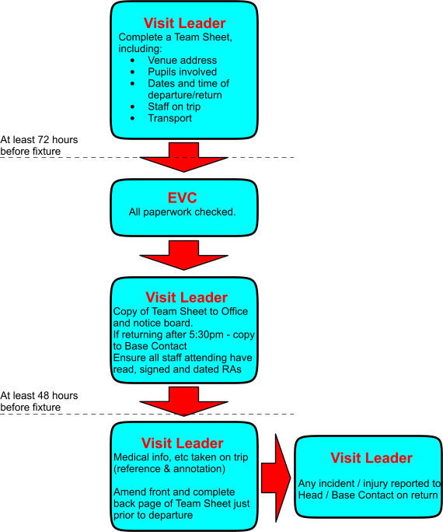

If teams are due to return after 5:30pm, a base contact must be arranged and the itinerary and expected return time of the trip known by them. Once the trip has returned, the Base Contact should be informed.

24.2 Procedure for Category 1 day trips and extended day trips
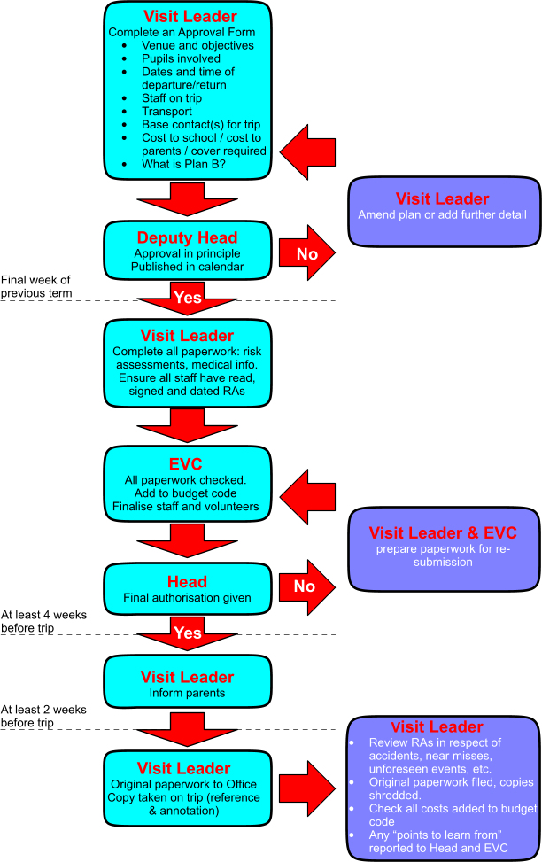

24.3 Procedure for Category 2 trips
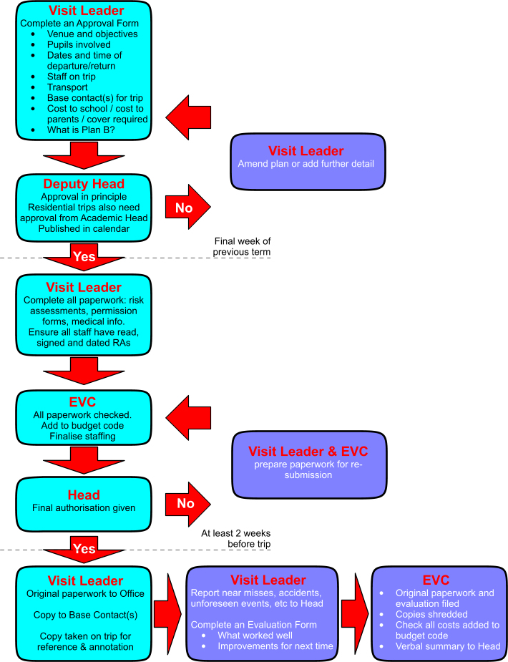

Appendix A: List of Forms Available

The following forms are available to assist with planning:
- Approval in Principle Form (Appendix B)
- Guidance for Supervisors (Appendix C)
- Letter to Parents: Outline of details to include (Appendix D)
- Emergency Procedure (Appendix E)
- Code of Conduct for Residential Trips (Appendix F)
- Checklist for Visit Leader at the point of departure (Appendix G)
- Educational Visit Evaluation Form (Appendix H)
- Guidance for Volunteers (Supervisors) (Appendix I)

Appendix B: Application for the Approval of an Educational Visit
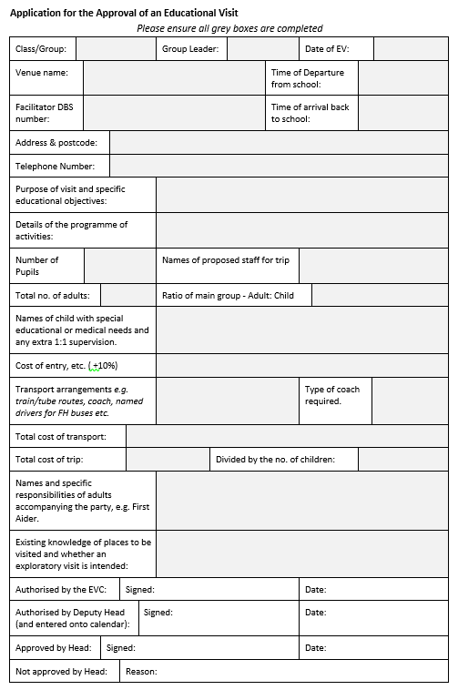

Appendix C: Guidance for Supervisors
Guidance for Volunteers on School Trips
Thank you for volunteering to help with educational trips. Below are some guidelines which we would appreciate you reading prior to the trip.
Before the trip
- Please ensure that you have read and understood the Risk Assessment for this particular trip, provided by the class teacher.
- Ensure that you have collected from the teacher a list of children for whom you are responsible.
- Check to see whether you have a current DBS check, as volunteers without should not be left alone with children out of sight of FH staff.
- If you are unable to be in school, please let the Class Teacher know either in person
or by telephoning the office.
During the trip
- Ensure that you have all children must stay within your sight at all times.
- Unfortunately, due to the health and safety concerns of the pupils, volunteers are unable to have their own child in their group.
- The class teacher is responsible for ALL first aid and medication.
- The class teacher leads the rules, routines and expectations for the day. Please help the teacher by ensuring your group follows all instructions e.g. when to eat and drink.
- If there is a medical or other emergency, let the class teacher know immediately. The class teacher is responsible for contacting the school in emergency situations.
- If you need to leave your group for any reason, please inform another adult.
- If appropriate, children will be permitted to bring their own money on the trip. This should not be supplemented in any way nor gifts bought for individual children or groups.
- Please encourage the children to be independent - we expect children to try everything themselves before we help them.
- Please do not lift, carry or move a child in any way.
- Please do not take photos of the children nor share photos of the trip on any form of social media.

After the trip
- If you have any queries or problems concerning the trip, please direct these in the first instance to the Class Teacher, or if you would rather, the Headteacher on return from the trip.
Confidentiality
It is very important that all staff and volunteers working in the school work to a policy of confidentiality. There may be occasions when certain pupils struggle, either academically or socially. You may hear or see other information concerning a child during the trip. It is vital that you do not share anything about specific children with anyone who is not a member of FH staff. The teachers have the responsibility of informing parents of any concerns about a child. Owing to data protection requirements, please return all paperwork to the teacher.
Thank you once again for giving your valuable time. Your help is very much appreciated and ensures that we are able to provide a fun and engaging learning experience for children.

Appendix D: Checklist of Information that May be Included in a Letter to Parents
• Dates of visit.
• Visit aims, objectives and expected learning outcomes.
• Times of departure and return.
• The location where children will be collected and returned.
• Mode(s) of transport and name of any travel company facilitating the visit.
• Size of the group.
• Level of staff supervision and whether any remote supervision will be taking place.
• children’s responsibilities for their own health, safety and wellbeing.
• Accommodation details.
• Arrangements for dealing with children who become ill.
• Arrangements for providing for special educational and medical needs, and disabilities
• Name of the Visit Leader and minimum number of accompanying staff.
• Full range of planned activities.
• Clothing and equipment requirements.
• Insurance arrangements.
• Pocket money recommendation.
• Costs and cancellation terms.
• Emergency contact details.
• Policy for the use of mobile phones and other electronic devices by the children.

Appendix E: Emergency Procedure for the Visit Leader
1. Assess the situation & make everyone safe.
2. Administer first aid & call 999 (UK) or 112 (UK and EU).
3. Deploy staff effectively to ensure welfare of the group.
4. Call the Base Contact ready to give the following information:
  - Your name and telephone number
  - What happened, to whom, where, when
  - What has happened since
  - Which local emergency services are involved
  - If a fatality is involved, has this been confirmed? By whom?
The Base Contact will liaise with the EVC and Headteacher to contact parents, relevant staff as necessary and deal with all matters. However, you must arrange to keep in touch.
5. Do not let the group telephone home until contact with the Base Contact has been made and the action approved by the Headteacher or SLT.
6. Arrange for the group to return to base; the base contact may need to help with arrangements.
7. Do not speak to press/media, other than to say “an official statement will be made through the Chairman of the Governors or Headteacher as soon as possible”
8. Do not admit liability of any sort to anybody, other than on the legal advice from the school or its representatives.
9. Do not allow anyone apart from medical services to see any children without a member of staff or supervisor being present
10. Keep a written record of all that happens.
11. If you change location let your base contact know.
Secondary action
1. Arrange appropriate protection from the elements.
2. Uninjured group members should be moved to shelter or away from the immediate vicinity of any casualties. Ensure that they:
  - are adequately supervised throughout
  - are returned as early as possible to base
  - receive appropriate support and reassurance.
3. Avoid splitting the group – unless it is the only way to get help – and leave nobody on their own.
4. Manage the incident - ensure that all appropriate actions have been/are being attended to.
5. It is useful to keep an accurate record of events and actions as close to real time as possible. Any leader with spare capacity should, therefore, keep notes – see Section 21 of the EV Policy about recording an incident.
6. Ensure that an appropriate adult accompanies any casualties to hospital, taking with them parental consent forms and appropriate medical information for the injured persons.
7. Maintain contact with the emergency services and the Establishment/Employer contact until the Emergency is over.
8. Monitor, reassess and review – ensure nothing has been forgotten and all leaders and children are coping, cared for and secure.
9. Consider other people who may need contacting:
  - Police
  - Embassy/Consulate if abroad
  - Local accommodation/contact
  - Tour operator/provider
  - Insurer
  - names and contact details of witnesses.
  - proposed actions.
Post-Incident action
1. Consider the emotional needs of any leaders or children who may have been adversely affected.
2. Follow the school’s reporting requirements, including completing any accident and incident forms and complying with RIDDOR regulations.
3. Review the lessons learned and ensure that these feed into future visit plans, emergency plans and staff training.
4. Share the experience and learning with colleagues.
Media/legal points
- Do not admit anything.
- Do not sign anything.
- Avoid discussing legal liability with others.
- Do not talk to the press – refer them to your employer’s media contact.
- Record all events, times and details – establish witness contact details and get statements fromleaders.
All situations are different; the Headteacher and SLT will make themselves available to offer you advice and support. Use them as much as you need.

Appendix F: Code of Conduct for Residential Trips
Children are expected to behave appropriately at all times by adhering to the code of conduct below. Any child not doing so may have to return to school.
Children should try to uphold the Finton House Values at all times and to exhibit the behaviour expected by the school.
All reasonable supervision will be exercised by accompanying staff, but children are also expected to take personal responsibility for their own safety.
Where children are asked to be in groups for their own safety they must stay in those groups.
Children must take responsibility for their possessions, which should be named. Should they lose items they need to understand that it may not be possible to take the time from the trip to find them and staff may not be in a position to spend time looking.
Pupils should be aware of the needs of other children, and to be supportive of each other.
Pupils should show awareness of other schools and members of the public.

Appendix G: Checklist for Visit Leader at Point of Departure:

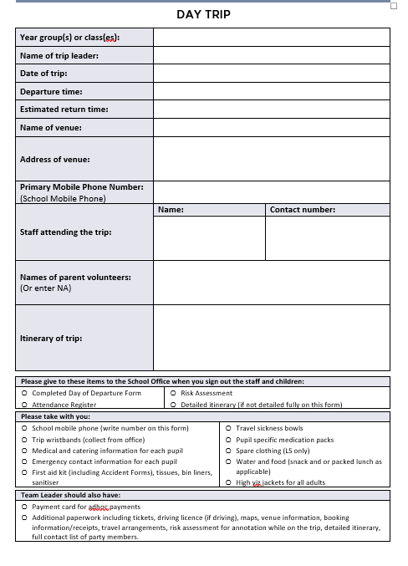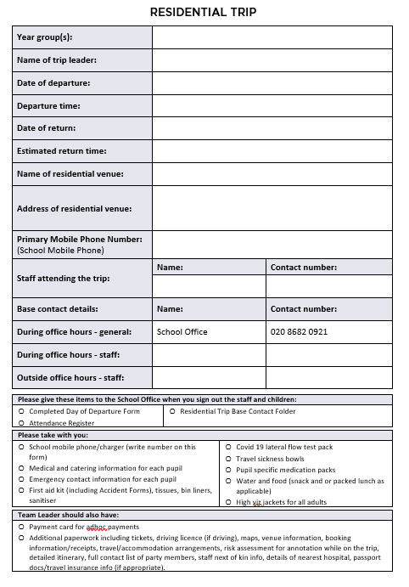
Has a list of names of staff and children actually departing on the trip been left with the office?
Are the following ‘on board’?
- all documents covering booking, travel arrangements and accommodation;
- copies of visit paperwork, including signed medical consent forms;
- insurance details and documents;
- passport documents (where appropriate);
- details of medical and emergency contacts for the group;
- a detailed itinerary (where appropriate);
- an appropriate first aid kit, including individual medication (inhalers, epi-pens, etc) and Health Care Plans;
- bucket/bowl, tissues, bin liners;
- kit bags (where appropriate);
- water;
- driving licence if driving;
- road map (if driving);
- a debit/credit card, or means to access emergency funds;
- a full list of the group members;
- details of weather forecasts (where appropriate);
- details of nearest hospital (residential and visits outside M25 only);
- Hi viz jackets for staff;
- Wrist bands for pupils;
- one, and preferably two, mobile telephones with charger;
- Spare clothes (LS only).
- Check the children have a packed lunch/tea (where appropriate);

Appendix H: Evaluation Form

Would you like to repeat the trip in the future? Y/N

Do you feel the EV was good value for money? Y/N

How would you rate the EV from a teaching and learning perspective? 1-5 (poor – outstanding)

How would you rate the EV in the broader sense of pupil engagement and fun?

Did your risk assessment meet all the risks of the trip? Y/N

If not, what would need to be addressed for a future visit?

What other adjustments if any will need to be made for a future visit? E.g. change of itinerary

Appendix I: Statutes and Further Guidance
The main statutes affecting outdoor learning, offsite visits and learning outside the classroom include:
  - Health and Safety at Work etc. Act 1974.
  - Management of Health and Safety at Work Regulations 1999.
  - Activity Centres (Childs' Safety) Act 1995.
  - Children Act 2004.
  - Childcare Act 2006.

Further guidance can be found at http://oeapng.info/ This website provides updated national guidance on all aspects of Educational Visits.

