Member(s) of staff responsible: Nicholas Lane and Lettie Coad
Date Revised: September 2023

PSHEE POLICY
A copy of this policy is available to all governors and parents via the school website or a hardcopy on request from the School Office. It is accessible to all staff electronically (in the Policy folder on the Staff Admin Drive) and a hardcopy held on file in the Head’s Office. This policy applies to all at the school including those in Reception (the EYFS).
Please read this policy alongside the following relevant polices:
- Curriculum Policies RSE, Computing, Science, PE
- Child Protection and Safeguarding Policy
- Pastoral Care Policy
- Positive Mental Health and wellbeing
- Equal Opportunities
- Acceptable use agreement and Technology Policy
- SMSC Policy
- Anti-Bullying Policy
This policy was written in conjunction and with consultation from with the following sources:
PSHEE Association, Government guidance 2020, KCSIE 2022, Coram Life Education, 2010 Equality Act. Childnet, Unicef, Human Rights Act 1998
This policy takes into account the current statutory guidance published by the Department for Education (Relationships Education, Relationships and Sex Education (RSE) and Health Education 2019)’
Additional documents consulted in the writing of this policy include:
- Better Health, Every mind matters (2021)
- Promoting Children and Young People’s Emotional Health and Wellbeing – A whole school or college approach (2021)
- Education Act (2011)
- Learning and Skills Act (2000)
- Education and Inspections Act (2006)
- Equality Act (2010)
- Supplementary Guidance for RSE for the 21st Century (2014)
- Keeping Children Safe in Educations – Statutory Safeguarding Guidance (2021)
- Children and Social Work Act (2017)
- Relationship Education, Relationships and Sex Education (RSE) and Health Education (June 2019)
- PSHE Association guidance on SRE (2018)
- Parental Engagement on Relationships Education’ (2019)
- Mental health and behaviour in schools’ (November 2018)
Taught PSHEE has been part of the Independent Schools Standards since 2014.
(For more details see DfE publications, ‘Sexual Violence and Sexual Harassment between Children in Schools and Colleges’ and KCSiE 2022 https://www.gov.uk/government/publications/sexual-violence-and-sexual-harassment-between-children-in-schools-and-colleges, , ‘Sexual Offences under the Sexual Offences Act 2003))

Contents
1. Introduction 3
2. Aims and objectives 3
3. PSHEE Curriculum 5
4. Lesson Allocation 6
5. Teaching and Learning 6
6. Assessment, Monitoring and Reporting 7
7. Appendix 1 – The Finton Goals 8
8. Appendix 2 – PSHEE Curriculum Overview 9
9. Appendix 3 – PSHEE Resource books 10

- Introduction
At Finton House, PSHEE is a timetabled subject taught each week and with the Finton Goals forms an intrinsic part of the ethos of the school, which is reflected in other curriculum areas and assemblies. PSHEE is taught from Reception (EYFS) to Year 6. Finton House aims to educate the ‘whole child’, throughout the school day, in and out of lessons. We believe that PSHEE cannot wholly be taught in isolation for it to be successful. As a result all staff are responsible for delivering the aims of PSHEE in the school (see below for aims). Within the school a calm, safe and secure learning environment is created for personal and social development and the development of self-esteem. It is an environment of trust and one of non-judgmental attitudes.
PSHEE has contributions to make in developing the children’s confidence and sense of responsibility, in preparing them to be active citizens, in developing healthy and safer lifestyles and in helping them to form good relationships and to respect their spiritual, moral, social and cultural development. As such, PSHEE is essential to ensuring that children at Finton House School are effectively prepared for life in British society.
PSHEE promotes spiritual development through fostering children’s awareness and understanding of issues that involve differing beliefs and values in human society. It helps children to develop self-knowledge through an exploration of their identity and belonging, their ideals and the meaning they see in life. It aids their moral development through helping them to acquire a critical appreciation of issues of right and wrong, justice, fairness, rights and obligations in society. It promotes social development through helping children to acquire the understanding and skills they need to become responsible and effective members of society. Cultural development, of which the Assistant Head: Culture coordinates, is promoted through helping children to understand the nature and role of the different groups to which they belong, to learn about the diversity in society and to develop respect for difference.
- Aims and objectives
Aims

Morality
- To foster a sense of social and moral responsibility.
- To ensure that children are effectively prepared for life in British society; enabling children to distinguish right from wrong and to behave appropriately online (see Child protection and Safeguarding Policy and Acceptable Use Agreement).
- To promote and develop the personal attributes through our Finton House Goals which reflect the school’s aims and ethos.

Self-Belief
- To develop confidence in talking or writing about their opinions and to explain their views on issues and events that affect themselves, society and the world.
- To recognise their worth as individuals by identifying positive things about themselves and their achievements and in so doing promote self-awareness, self-esteem and self-confidence.

Communication
- To equip pupils with the confidence and tools to report any issues involving disrespect within a friendship specifically with child on child abuse (see Child Protection and Safeguarding Policy 2022)
- To appreciate that their bodies are their own and special and to learn what they should do to safeguard themselves if they don’t like what is being done to them, i.e. child on child bullying and child on child abuse.

Respect
- To promote mutual respect and tolerance of others through understanding different types of lifestyles, faiths, disability, beliefs and relationships, paying particular regard to the Protected Characteristics set out in the 2010 Equality Act.
- To ensure pupils understand that equal opportunity, treatment and respect is given to the Protected Characteristics being age, disability, gender reassignment, marriage and civil partnership, pregnancy and maternity, race, religion or belief, sex, and sexual orientation.
- To ensure pupils see all races and religions as equal.
- To enable pupils to understand the importance of male and female pupils being treated with the same respect.
- To teach that all marriages and unions are of equal acceptance.
- To specify to pupils that those with disabilities are offered equal opportunities and treatment.
- To ensure respect and understanding of what different families look like for example same sex parents, single parent families.
- To encourage children to gain a respect for others, paying particular regard to the issues of gender, stereotyping, individual liberty, prejudice, discrimination, beliefs, or race. To encourage an appreciation and respect for their own and other cultures whilst building resilience to radicalisation through the promotion of fundamental British values.
- To understand the nature of democracy, dictatorship and a communist state and to encourage respect for the fundamental British values of democracy. To support the participation in the democratic process and to respect the basis for how the law is made and applied in England.

Curiosity
- To provide a safe place to debate controversial issues such as terrorism and extremism, to be aware of the risks associated with them and to enable children to challenge extremist views.
- To develop a sense of citizenship through understanding how a community works and to facilitate an understanding of the contribution they can make to their community through active involvement and participation.

Kindness
- To understand the concept of disability and to act in a caring, but appropriate manner to those with special needs, both educationally and socially. As a result, to seek confidently a wide variety of relationships and to adopt appropriate behaviour.
- To know how to develop a healthy mind by identifying difficult emotions and through a range of techniques, including mediation practice, be able to develop a present and calm mind.
- To learn about health risks and safety issues and how to respond in an emergency, i.e. drugs, nicotine, eating disorders, alcohol, fire, water, accidents, 999 calls and basic first aid.

Objectives:
- To know about public institutions and services in England.
- To know about global environmental issues, knowing how precious all life is on earth and how we all have a responsibility to take care of it.
- To know about people who have made a difference in the world and to consider how they could themselves perhaps make a difference.
- To know about the concepts of ‘interest’, ‘loan’, ‘debt’, and ‘tax’ (e.g. their contribution to society through the payment of VAT)
- To know the role money plays in their own and others’ lives, including how to manage their money and about being a critical consumer.
- To know how to live healthily, making informed and reasoned choices.
- To recognise, as they approach puberty, how people’s emotions change at that time and how to deal with their feelings towards themselves, their family and others in a positive way. As well as beginning to develop understanding as to how to approach sexual relationships in both a respectful and safe manner.

- PSHEE Curriculum
Throughout the school, all classes have timetabled PSHEE sessions each week. The termly focus for PSHEE are based on Health and Wellbeing, Relationships and Living in the Wider World (see PSHEE overview – appendix 2). These are linked where appropriate to other curriculum areas e.g. RE, science and maths. The PSHEE objectives are also sometimes the focus of class time.
In addition to the subject objectives, learning opportunities in PSHEE are further enhanced by the following extra-curricular and cross-curricular events:
  - E-safety teaching (see Computing SOW) and annual workshops run by Childnet.com
  - Cycle training
  - Road Safety
  - Pupils’ Council
  - Y6 Positions of Responsibility
  - Drop in mindfulness
  - Mentor groups

The Finton House Goals
The Finton House Goals (see Appendix 1) help develop pupils’ personal attributes. They underpin teaching and learning opportunities and are introduced and reinforced in assemblies. Assemblies are led by teachers, classes and external speakers and are organised by the PSHEE coordinator and the Phase Leaders. The goals are rewarded by the giving of Finton Goal Stickers and the awarding of the weekly commendation certificates. Good behaviour house points’ are also linked to school rules and the Finton Goals.
Pupil Council
Pupils’ Council is used in conjunction with the PSHEE objectives, where the Finton House Goals help to develop the character qualities which will prepare and enable children to take an active part in British society (see Pupil Council Policy). The Fundamental British Value of democracy is modelled by the election of a Pupils’ Council representative for each class by their peers. The representative from each class presents the views of their peers to the rest of the council on a termly basis. The Pupils’ Council is a means for the children to raise issues, concerns and to suggest ideas for their school and ways they could make a difference in the local and wider community.
The Pupils’ Council is chaired by the Head Girl and Boy. Class discussions take place at the beginning of each term and key points from these discussions are then raised at the Pupils’ Council meeting. There is also a suggestion box for children to post ideas. Assemblies are used to feedback and share the latest projects.
Pupil voice
- Year 6 pupil responsibilities allow pupils to direct one area of the school e.g. STEM, Music, House Captains, School reporters, Sports, Library and Art Monitors. The staff use this to gain valuable feedback about their area and listen and respond to pupil voice.
- A key element of the Houses System is to support charities, and this involves fundraising for national charities demonstrating the pupil commitment to the lives of those in the wider community.
- Year 5 and 6 pupils are used as tour guides to prospective parents and are able to talk about daily life at Finton House and the highlights of their school journey.
- There are clear outcomes of pupil voice displayed at the entrance to the school and suggestions from pupils that have become a reality e.g. charity events
- Pupils complete the PASS survey from Year 2 upwards Pupils complete the PASS survey which demonstrates that they are able to evaluate their own self-understanding, self-esteem, self-confidence, self-discipline and resilience. Pupils identified as a concern are re-surveyed towards the end of the academic year to evaluate the impact of support and interventions.
- All pupils have the opportunity to share any worries and concerns and are reminded how to do this on posters around the school e.g. Frog VLE Page, named adults, worry box
- Year 5 and 6 pupils are asked to complete a PSHEE/RSE survey annually and this gives them a chance to express their views on the subject and helps us to understand how we can improve.

- Lesson Allocation
- All classes have a timetabled PSHEE lesson each week.
- In addition, there are timetabled Class Time sessions each week when teachers can address topical or pastoral issues.
- Assemblies are used as an opportunity by both staff, visiting speakers and children to develop and reinforce aspects of the PSHEE curriculum.
- In addition to teaching mindfulness programmes through Paws B in Y4, .Breathe in Y6, and dots in Y2, there is also a lunchtime drop in session available for Years 2 to 6. All of which support mental health.
- Zones of Regulation are taught in Year 2 (class time), Reception and Year 3 (curriculum time) and are part of the language of every classroom. There is also an early morning session to which children requiring extra support are invited to attend.
Please see the Curriculum Policy for further details regarding lesson allocation.
- Teaching and Learning
How PSHEE is taught

- Predominantly, PSHEE lessons are taught to the whole class and, where appropriate, individual or group work tasks are differentiated. The emphasis is on first-hand experience and we encourage children to take control of their learning. Groups may be mixed or of a similar ability level.
- Learning in PSHEE is most effective when it is central to the culture and ethos of the school. Accordingly, it forms the focus of assemblies through the personal goals (see section 3) which are delivered by members of staff and external speakers.
- Curriculum PSHEE is taught through a range of different methods depending on the age group of the children. There are many opportunities for cross curricular links in PSHEE. In Year 5 and Year 6, for example, many of the RSE (relationships and sex education) objectives are covered in science lessons. Owing to the nature of the subject, there are many opportunities for cooperative learning; the children being placed in mixed ability groups.

Learners

- Some pupils with Special Educational / Learning Needs are supported by a Teaching Assistant and more formal learning is recorded on sheets or in books which allows for differentiation.
- Pupils with Social and Emotional Mental Health needs are supported in and out of class by assistants and specialist teachers. Should specific topic support be needed resources are adapted as necessary.

Resourcing

- Resources to support lesson planning and teaching are stored in the Emma Thornton building. This cupboard contains fiction and non-fiction books for children along with general books for teachers’ use. These focus on activities to develop self-esteem and for circle time. Further teaching resources (books) are located in classrooms and resources for children are located in the library. New books available see appendix 3 and Frog PSHEE page.
- Online resources available to help support non-specialist teachers with lesson plans, are varied and the school subscribes to Coram Life Education annually. Teachers understand that they are able to contact Coram Life Education directly should they have any questions or require further information beyond the information that be provided by colleagues, Head of PSHEE and Deputy Head Pastoral.
- At Pastoral Meetings and Subject Co-ordinator meetings staff plan for any resources that are necessary and the PHSEE budget allows for request purchases. The Deputy Head Pastoral and Head of PSHEE liaises with the Librarian to ensure new resources are displayed and communicated to staff.
- Head of PSHEE and Deputy Head Pastoral are available for teaching support should any staff triggers arise with PSHEE topics.

Recording

- When appropriate, books are used to record learning. Books are used for Y2 to Y6 with Y1 working in folders and Reception in topic books. Where tasks are more practical, photos may be placed in books to record the learning that has taken place. Children annotate the photos where necessary.
- Although there is no formal homework for PSHEE, a range of resources and links are shared on Frog (VLE). The pupils are able to access these at home to consolidate and extend their learning.

Staff training

- Some PSHEE lessons are taught by non-class teachers e.g. Mindfulness. This is because the staff member has a specialty or training in this area.

- Class teachers are responsible for planning and teaching the PSHEE lessons using the PSHEE schemes of work. Support for delivering the lessons is supported by the PSHEE heads, inset is provided for any areas of need that are identified by staff:
(Inset Sept 2022 - It Happens) which signposted further support available to all staff for the teaching of PSHEE. Should specialist teachers be required to teach PSHEE there is full verbal communication, preparation and support for the teacher.

- Assessment, Monitoring and Reporting
- Assessment is carried out in a variety of ways to ascertain the children’s level of understanding of specific tasks and of their overall understanding of a PSHEE topic. Assessment methods include lesson observation, discussion, questioning and marking.
- Pupils will be assessed by observation in class, and questioned to ascertain both their level of understanding and knowledge, and their development of personal and social skills.
- Marking together with verbal feedback is intended to be constructive and in particular aims to raise each child’s self-esteem and encourage further thought.
- Book scrutiny is also used as a tool to monitor progress.

Please see the Assessment, Recording and Reporting Policy for further information.
- Appendix 1 – The Finton Goals
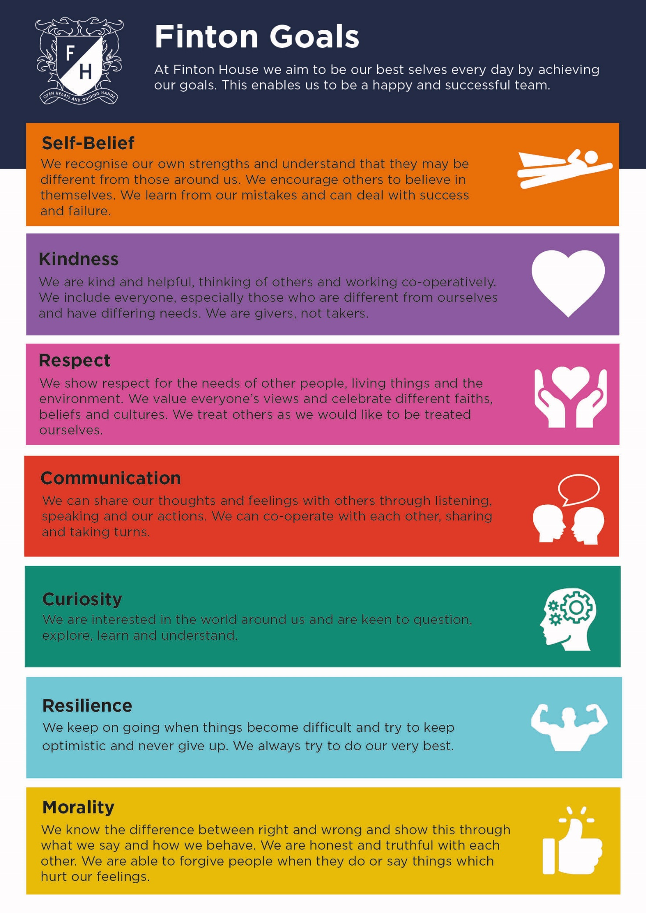

- Appendix 2 – PSHEE Curriculum Overview

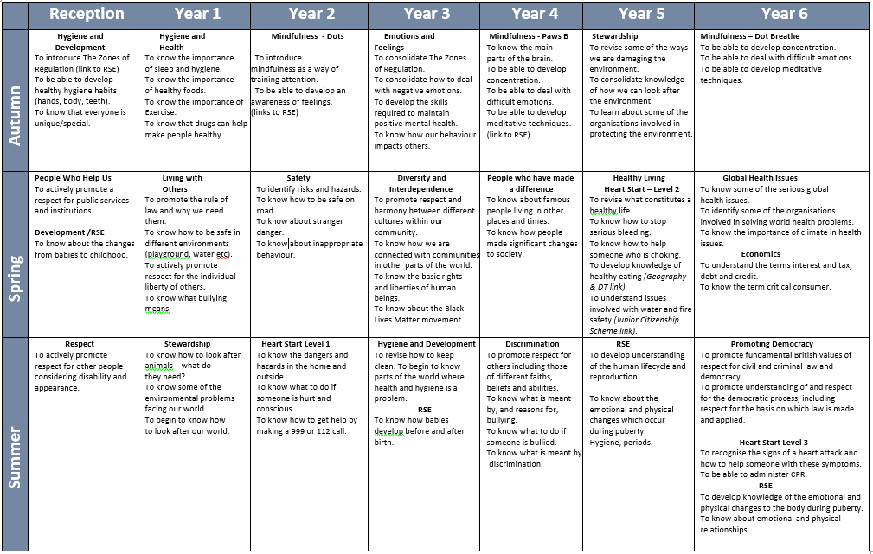

- Appendix 3 – PSHEE Resource books
